# Feature selection results for small_dataset and Nmin = 10

**Data1 = označava single peak emisije**

1. result: **(rise_time, pp3, peak_frequency)**

**Estimated Epsilon: 0.060683, Picked Epsilon: 0.078183, MinNumPoints: 10**

**DBCV index value: 0.82893**

**cluster -1 had 0.84746% single peaks**

**cluster 1 had 97.4576% single peaks**

**cluster 2 had 1.6949% single peaks**

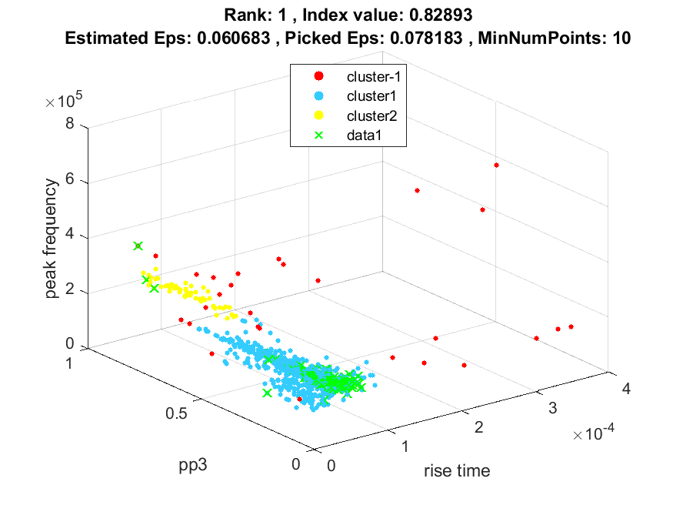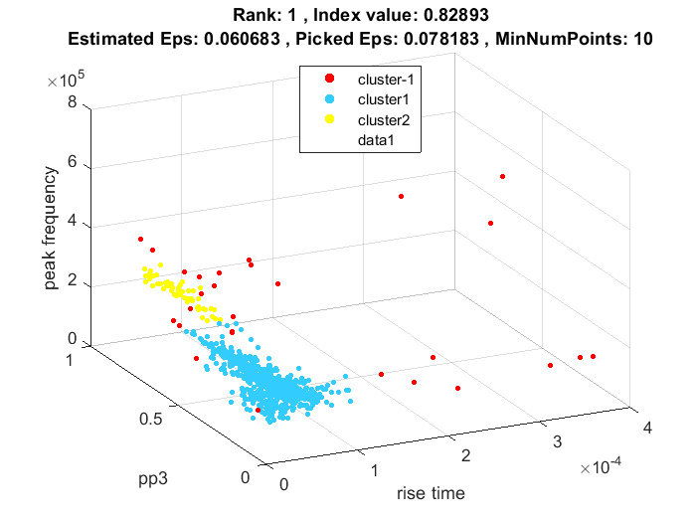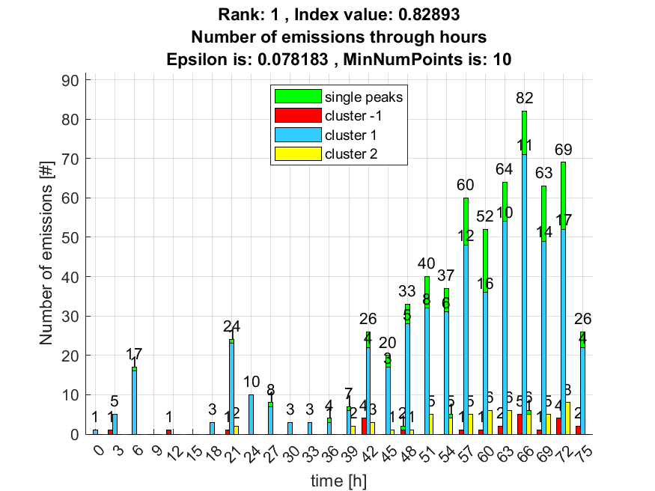

**2. result: (signal_strength, peak_frequency, amp_of_peak_frequency)**

**Estimated Epsilon: 0.028967, Picked Epsilon: 0.038967, MinNumPoints: 10**

**DBCV index value: 0.82434**

**cluster -1 had 7.6271% single peaks**

**cluster 1 had 91.5254% single peaks**

**cluster 2 had 0.84746% single peaks**

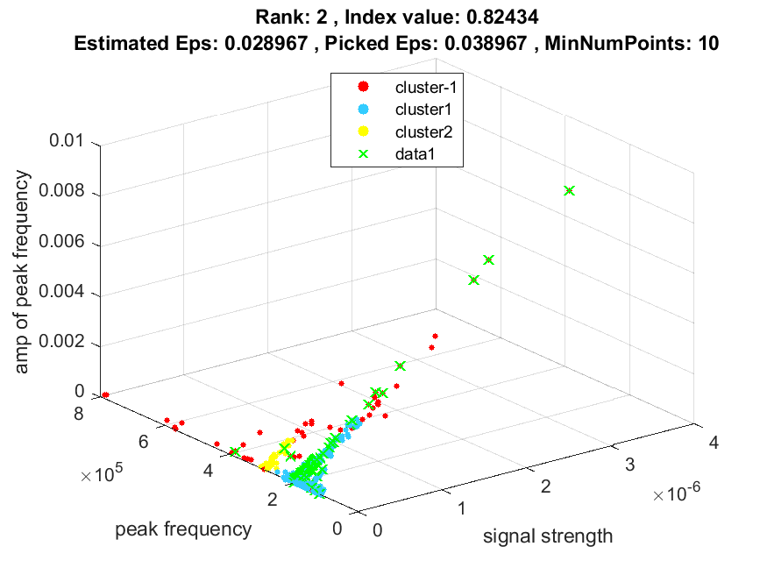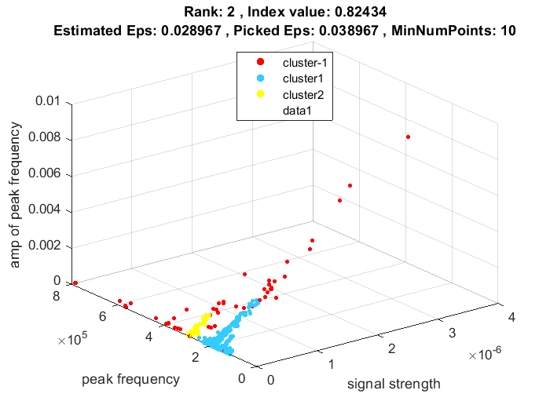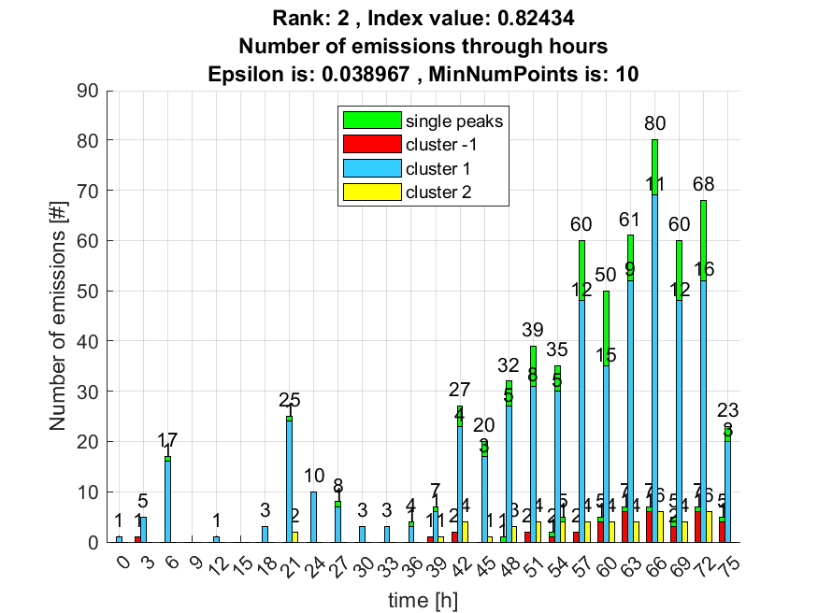

**3. result: (pp3, peak_frequency, fall_time)**

**Estimated Epsilon: 0.053576, Picked Epsilon: 0.063576, MinNumPoints: 10**

**DBCV index value: 0.81508**

**cluster -1 had 0.84746% single peaks**

**cluster 1 had 97.4576% single peaks**

**cluster 2 had 1.6949% single peaks**

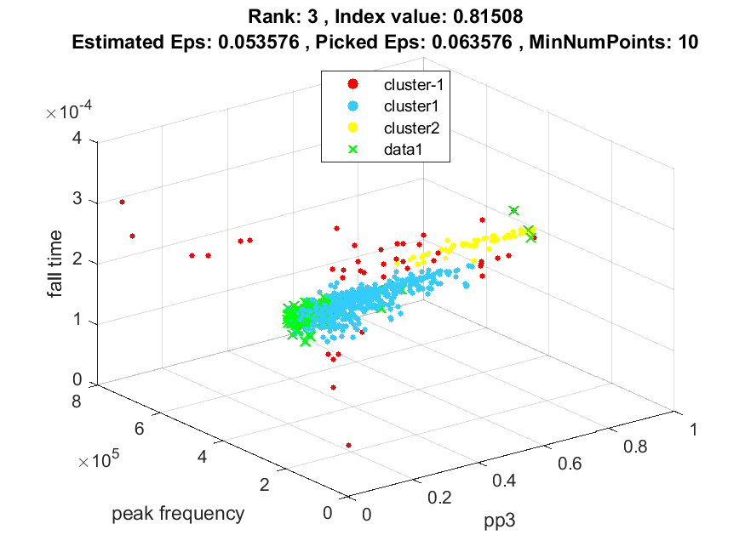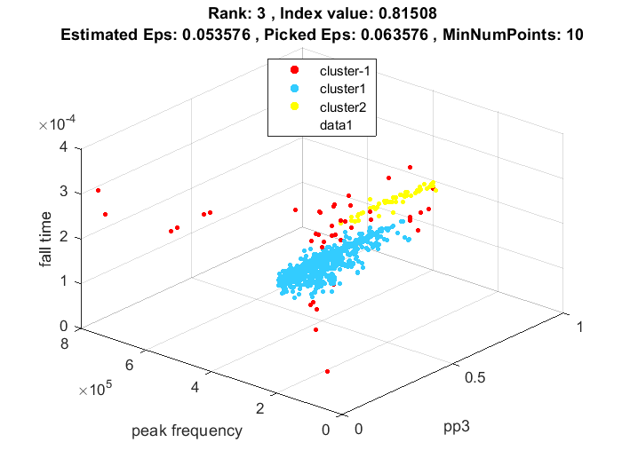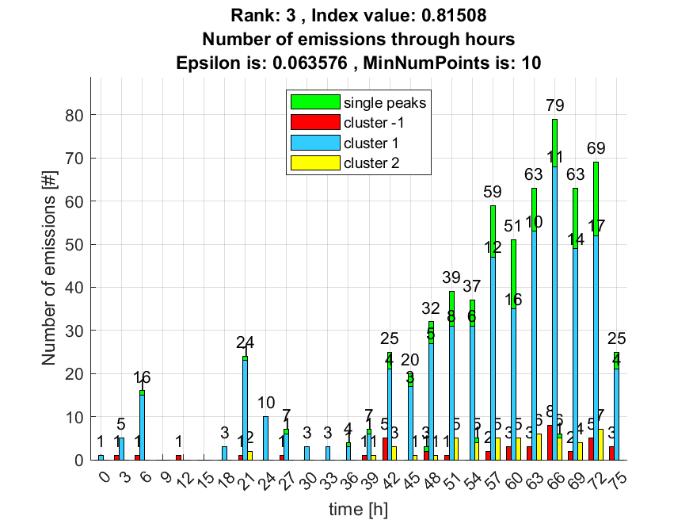

**4. result: (rise_time, pp2, peak_frequency)**

**Estimated Epsilon: 0.062609, Picked Epsilon: 0.075109, MinNumPoints: 10**

**DBCV index value: 0.81384**

**cluster -1 had 0.84746% single peaks**

**cluster 1 had 97.4576% single peaks**

**cluster 2 had 1.6949% single peaks**

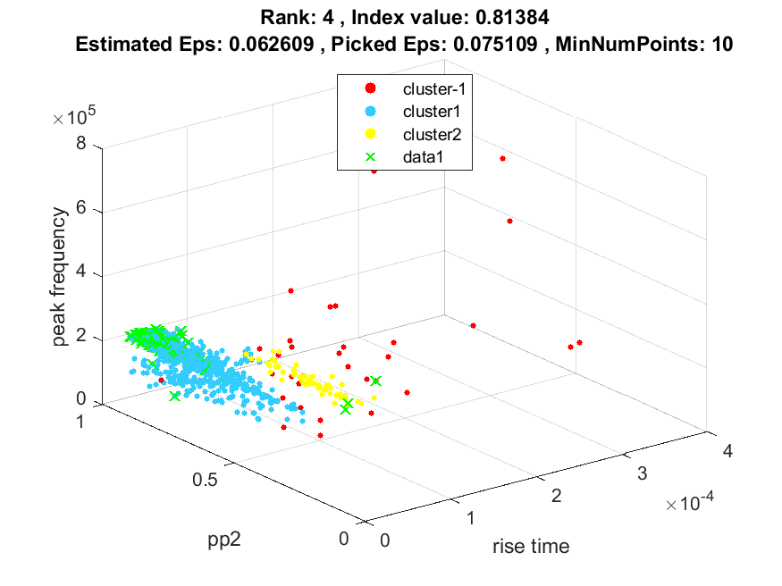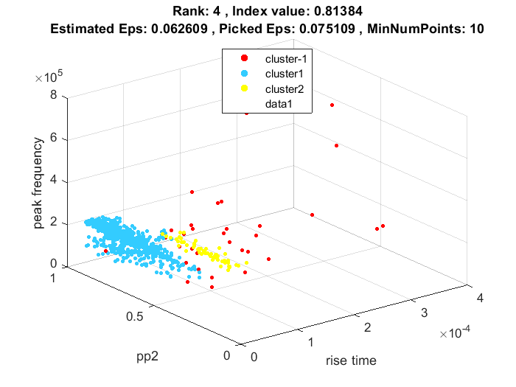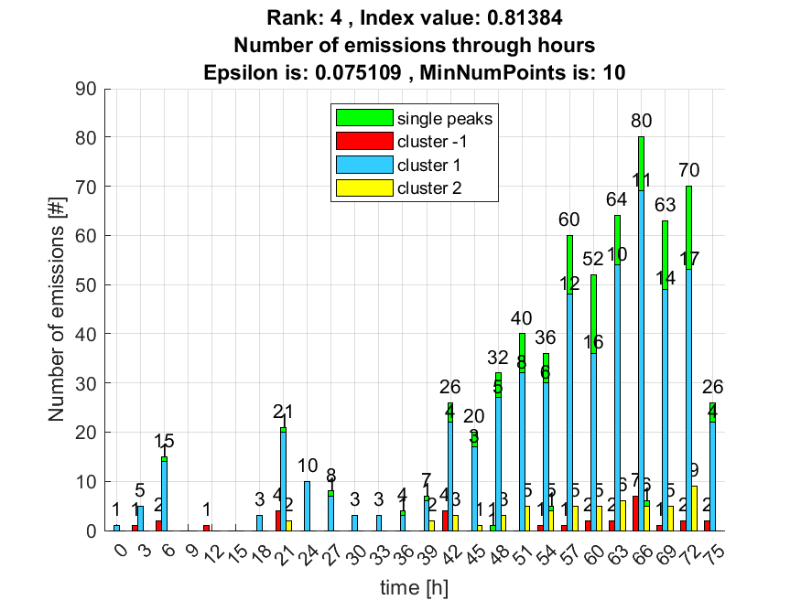

**5. result: (pp2, peak_frequency, fall_time)**

**Estimated Epsilon: 0.057304, Picked Epsilon: 0.069804, MinNumPoints: 10**

**DBCV index value: 0.80107**

**cluster -1 had 0.84746% single peaks**

**cluster 1 had 97.4576% single peaks**

**cluster 2 had 1.6949% single peaks**

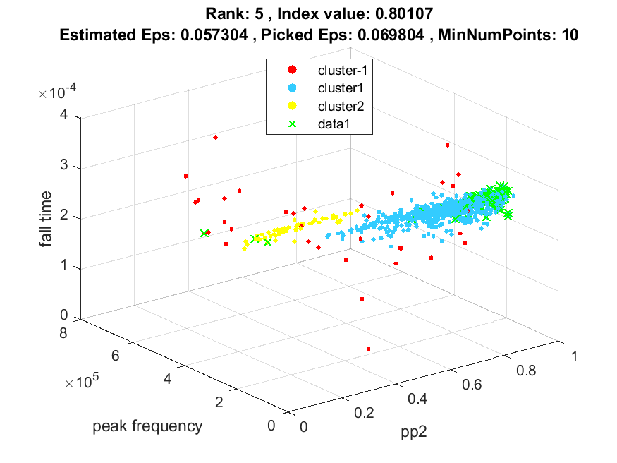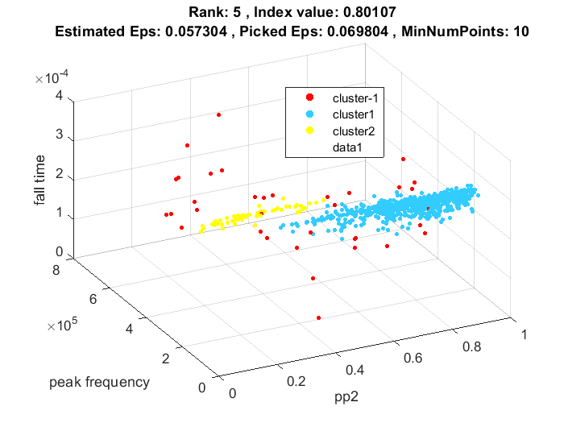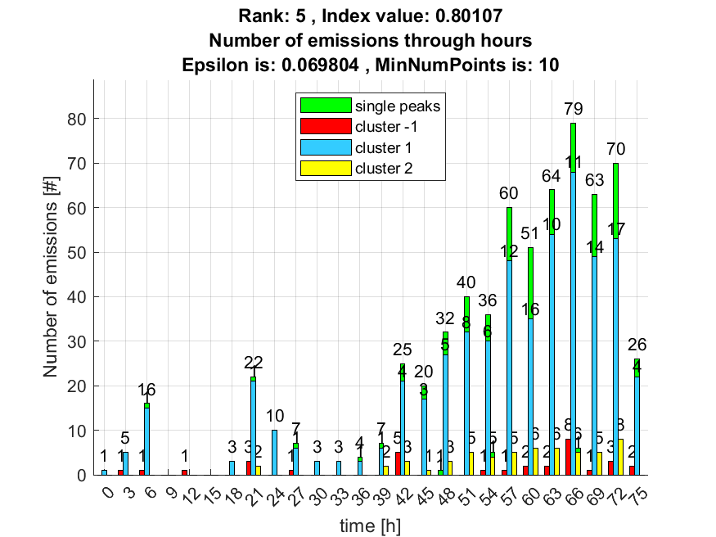

**6. result: (signal_strength, pp3, peak_frequency)**

**Estimated Epsilon: 0.069955, Picked Epsilon: 0.077455, MinNumPoints: 10**

**DBCV index value: 0.80043**

**cluster -1 had 6.7797% single peaks**

**cluster 1 had 91.5254% single peaks**

**cluster 2 had 1.6949% single peaks**

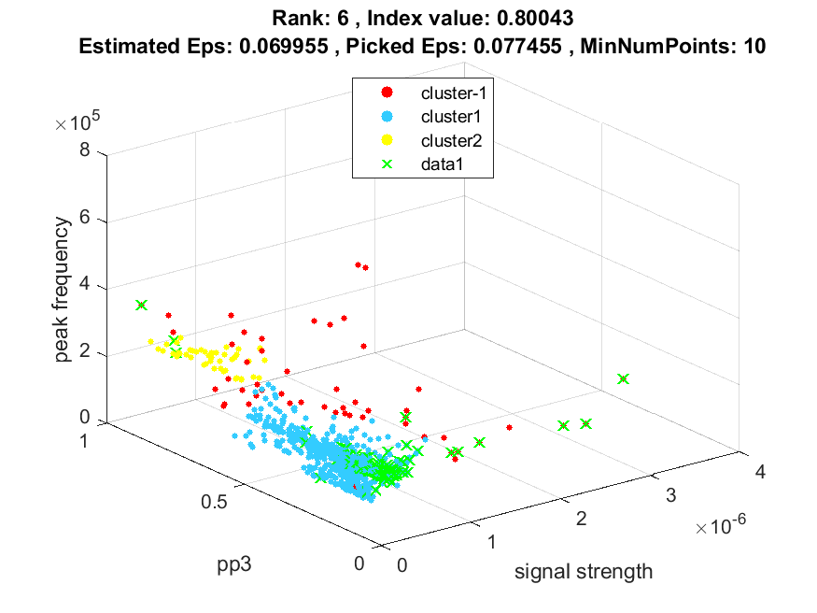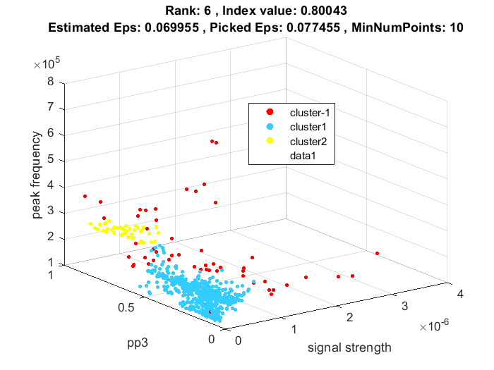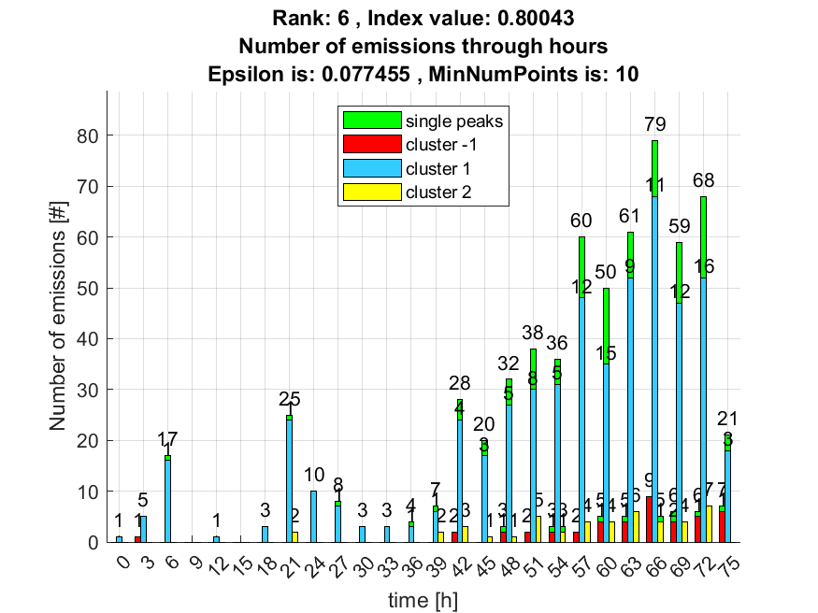

**7. result: (peak_amplitude, pp3, peak_frequency)**

**Estimated Epsilon: 0.069149, Picked Epsilon: 0.071649, MinNumPoints: 10**

**DBCV index value: 0.79969**

**cluster -1 had 5.0847% single peaks**

**cluster 1 had 93.2203% single peaks**

**cluster 2 had 1.6949% single peaks**

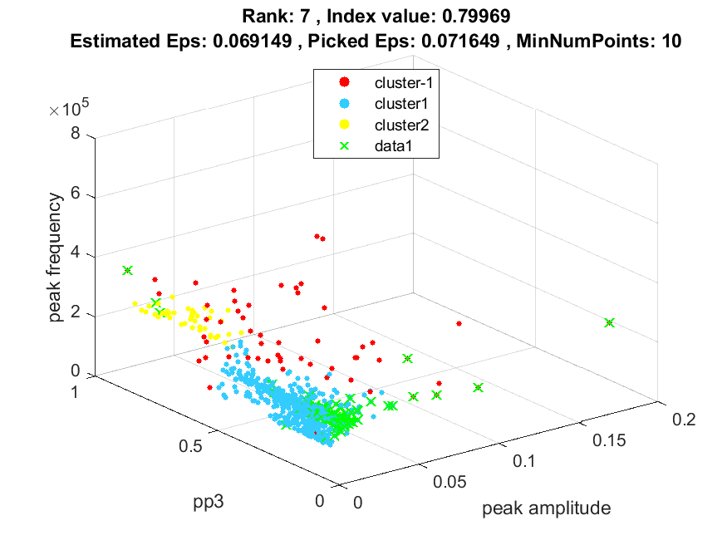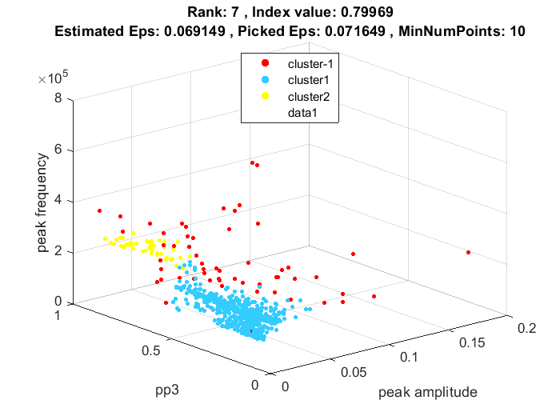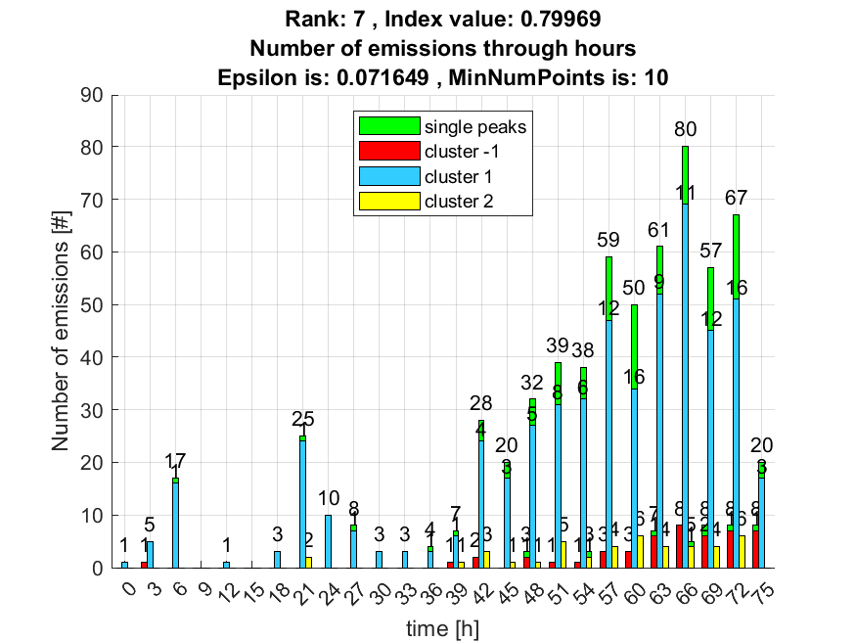

**8. result: (pp2, pp3, peak_frequency)**

**Estimated Epsilon: 0.072057, Picked Epsilon: 0.084557, MinNumPoints: 10**

**DBCV index value: 0.79796**

**cluster -1 had 0.84746% single peaks**

**cluster 1 had 97.4576% single peaks**

**cluster 2 had 1.6949% single peaks**

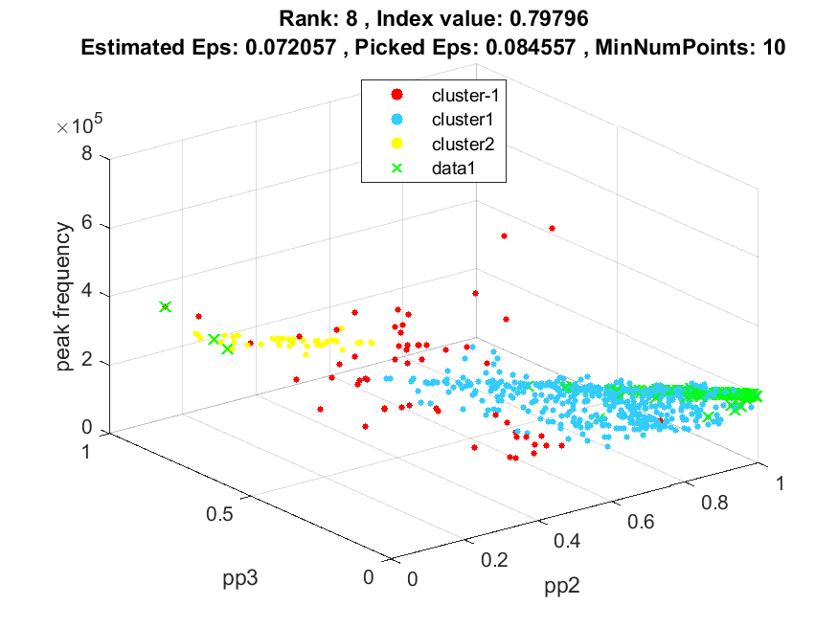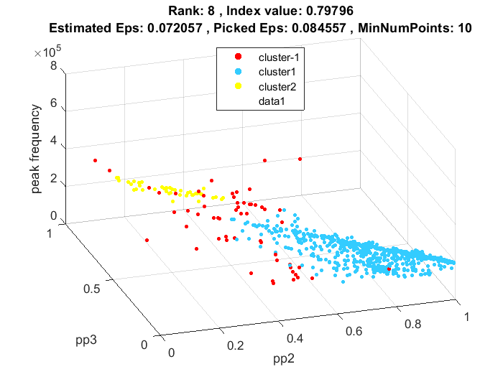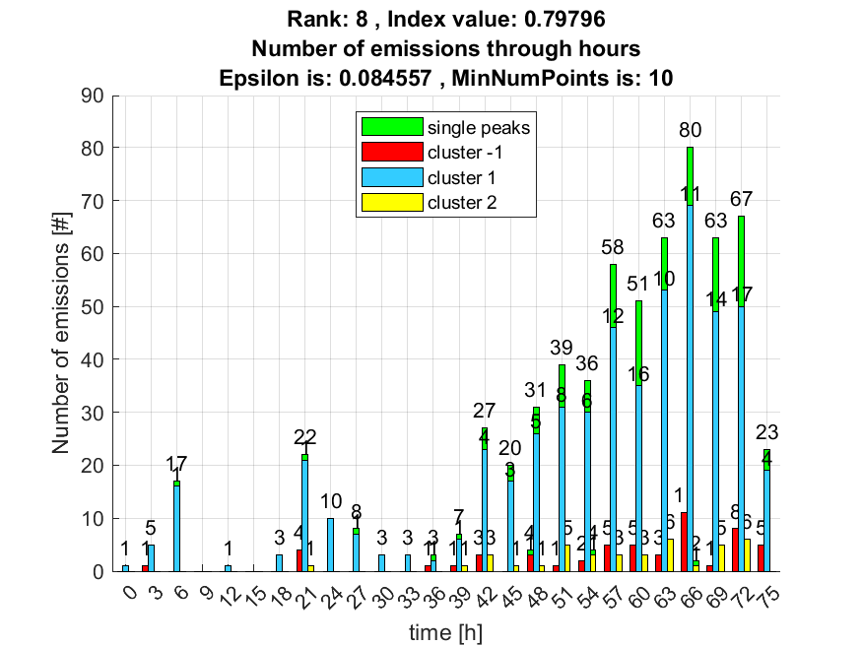

**9. result: (peak_amplitude, peak_frequency, amp_of_peak_frequency)**

**Estimated Epsilon: 0.04127, Picked Epsilon: 0.03877, MinNumPoints: 10**

**DBCV index value: 0.79701**

**cluster -1 had 9.322% single peaks**

**cluster 1 had 89.8305% single peaks**

**cluster 2 had 0.84746% single peaks**

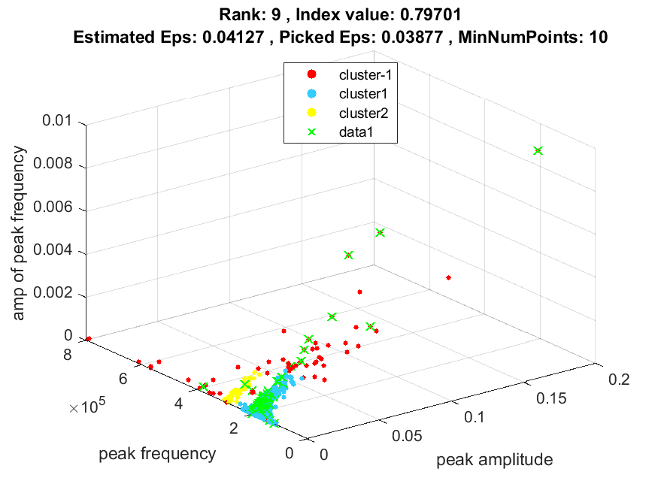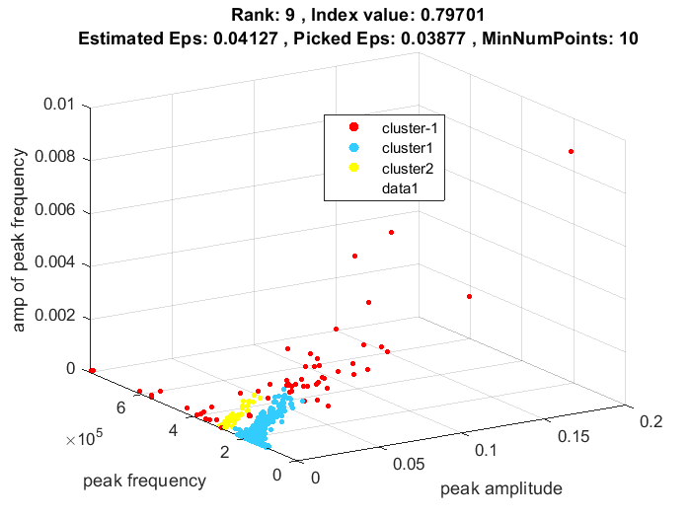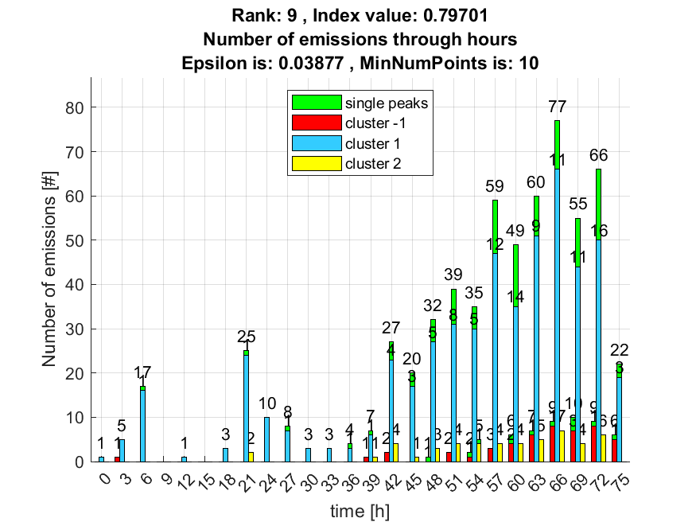

**10. result: (signal_strength, pp2, peak_frequency)**

**Estimated Epsilon: 0.060104, Picked Epsilon: 0.077604, MinNumPoints: 10**

**DBCV index value: 0.79369**

**cluster -1 had 6.7797% single peaks**

**cluster 1 had 91.5254% single peaks**

**cluster 2 had 1.6949% single peaks**

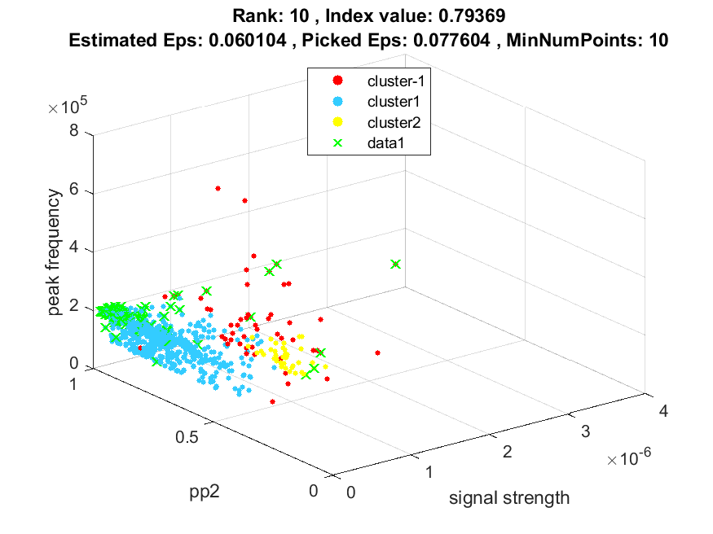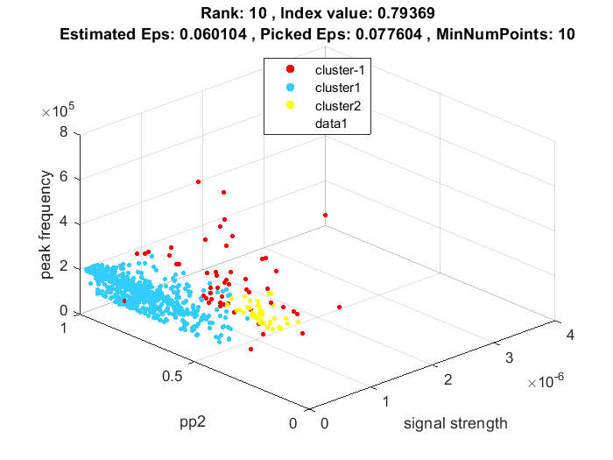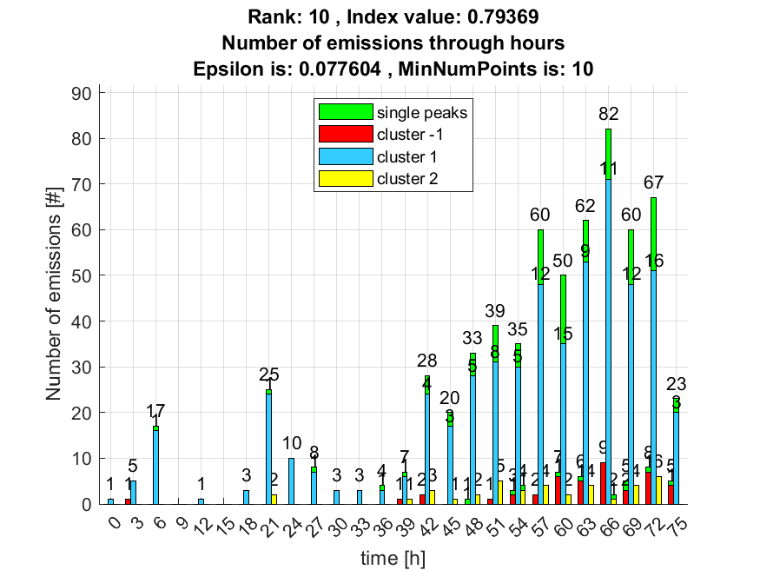

**Kao dodatna informacija priložio sam sličnosti navedenih 10 rezultata kao postotak sličnosti svih clustera između svih parova rezultata. Gdje je svaki red i svaki stupac predstavlja određeni cluster navedenog rangiranog rezultata. Clusteri idu po redu kako su označeni na slici uključujući outliere kao cluster označen s -1.**

**Intersection between rank 1 and rank 2 :**

**0.7179 0 0**

**0.0136 0.9864 0**

**0.0364 0 0.9636**

**Intersection between rank 1 and rank 3 :**

**0.7179 0 0**

**0.0136 0.9864 0**

**0.0364 0 0.9636**

**Intersection between rank 1 and rank 4 :**

**0.8235 0 0**

**0.0091 0.9879 0.0030**

**0 0 0.9649**

**Intersection between rank 1 and rank 5 :**

**0.8235 0 0**

**0.0091 0.9879 0.0030**

**0 0 0.9649**

**Intersection between rank 1 and rank 6 :**

**0.7179 0 0**

**0.0136 0.9864 0**

**0.0364 0 0.9636**

**Intersection between rank 1 and rank 7 :**

**0.6087 0 0**

**0.0211 0.9789 0**

**0.0727 0 0.9273**

**Intersection between rank 1 and rank 8 :**

**0.8235 0 0**

**0.0091 0.9879 0.0030**

**0 0 0.9649**

**Intersection between rank 1 and rank 9 :**

**0.4000 0 0**

**0.0302 0.9698 0**

**0.3143 0 0.6000**

**Intersection between rank 1 and rank 10 :**

**1 0 0**

**0 1 0**

**0 0 1**

**Intersection between rank 2 and rank 3 :**

**1 0 0**

**0 1 0**

**0 0 1**

**Intersection between rank 2 and rank 4 :**

**0.8718 0.0015 0.0702**

**0 0.9985 0**

**0 0 0.9298**

**Intersection between rank 2 and rank 5 :**

**0.8718 0.0015 0.0702**

**0 0.9985 0**

**0 0 0.9298**

**Intersection between rank 2 and rank 6 :**

**1 0 0**

**0 1 0**

**0 0 1**

**Intersection between rank 2 and rank 7 :**

**0.8478 0 0**

**0.0077 0.9923 0**

**0.0377 0 0.9623**

**Intersection between rank 2 and rank 8 :**

**0.8718 0.0015 0.0702**

**0 0.9985 0**

**0 0 0.9298**

**Intersection between rank 2 and rank 9 :**

**0.5571 0 0**

**0.0168 0.9832 0**

**0.2857 0 0.6226**

**Intersection between rank 2 and rank 10 :**

**0.7179 0.0136 0.0364**

**0 0.9864 0**

**0 0 0.9636**

**Intersection between rank 3 and rank 4 :**

**0.8718 0.0015 0.0702**

**0 0.9985 0**

**0 0 0.9298**

**Intersection between rank 3 and rank 5 :**

**0.8718 0.0015 0.0702**

**0 0.9985 0**

**0 0 0.9298**

**Intersection between rank 3 and rank 6 :**

**1 0 0**

**0 1 0**

**0 0 1**

**Intersection between rank 3 and rank 7 :**

**0.8478 0 0**

**0.0077 0.9923 0**

**0.0377 0 0.9623**

**Intersection between rank 3 and rank 8 :**

**0.8718 0.0015 0.0702**

**0 0.9985 0**

**0 0 0.9298**

**Intersection between rank 3 and rank 9 :**

**0.5571 0 0**

**0.0168 0.9832 0**

**0.2857 0 0.6226**

**Intersection between rank 3 and rank 10 :**

**0.7179 0.0136 0.0364**

**0 0.9864 0**

**0 0 0.9636**

**Intersection between rank 4 and rank 5 :**

**1 0 0**

**0 1 0**

**0 0 1**

**Intersection between rank 4 and rank 6 :**

**0.8718 0 0**

**0.0015 0.9985 0**

**0.0702 0 0.9298**

**Intersection between rank 4 and rank 7 :**

**0.7391 0 0**

**0.0092 0.9908 0**

**0.1053 0 0.8947**

**Intersection between rank 4 and rank 8 :**

**1 0 0**

**0 1 0**

**0 0 1**

**Intersection between rank 4 and rank 9 :**

**0.4857 0 0**

**0.0183 0.9817 0**

**0.3429 0 0.5789**

**Intersection between rank 4 and rank 10 :**

**0.8235 0.0091 0**

**0 0.9879 0**

**0 0.0030 0.9649**

**Intersection between rank 5 and rank 6 :**

**0.8718 0 0**

**0.0015 0.9985 0**

**0.0702 0 0.9298**

**Intersection between rank 5 and rank 7 :**

**0.7391 0 0**

**0.0092 0.9908 0**

**0.1053 0 0.8947**

**Intersection between rank 5 and rank 8 :**

**1 0 0**

**0 1 0**

**0 0 1**

**Intersection between rank 5 and rank 9 :**

**0.4857 0 0**

**0.0183 0.9817 0**

**0.3429 0 0.5789**

**Intersection between rank 5 and rank 10 :**

**0.8235 0.0091 0**

**0 0.9879 0**

**0 0.0030 0.9649**

**Intersection between rank 6 and rank 7 :**

**0.8478 0 0**

**0.0077 0.9923 0**

**0.0377 0 0.9623**

**Intersection between rank 6 and rank 8 :**

**0.8718 0.0015 0.0702**

**0 0.9985 0**

**0 0 0.9298**

**Intersection between rank 6 and rank 9 :**

**0.5571 0 0**

**0.0168 0.9832 0**

**0.2857 0 0.6226**

**Intersection between rank 6 and rank 10 :**

**0.7179 0.0136 0.0364**

**0 0.9864 0**

**0 0 0.9636**

**Intersection between rank 7 and rank 8 :**

**0.7391 0.0092 0.1053**

**0 0.9908 0**

**0 0 0.8947**

**Intersection between rank 7 and rank 9 :**

**0.6571 0 0**

**0.0093 0.9907 0**

**0.2571 0 0.6471**

**Intersection between rank 7 and rank 10 :**

**0.6087 0.0211 0.0727**

**0 0.9789 0**

**0 0 0.9273**

**Intersection between rank 8 and rank 9 :**

**0.4857 0 0**

**0.0183 0.9817 0**

**0.3429 0 0.5789**

**Intersection between rank 8 and rank 10 :**

**0.8235 0.0091 0**

**0 0.9879 0**

**0 0.0030 0.9649**

**Intersection between rank 9 and rank 10 :**

**0.4000 0.0302 0.3143**

**0 0.9698 0**

**0 0 0.6000**